Table of Contents
Table of Contents 0
1 Introduction 1
2 Specifications of the Game Requirements and their Analysis 2
2.1 Functional Requirements 2
2.2 Non-Functional Requirements 4
2.3 Analysis of the Game Requirements 4
3 Game Design 5
3.1 Game Map 7
3.2 Player 9
3.3 Enemy 10
3.4 Combat System 14
3.5 Saving and loading system 17
4 Implementation 18
4.1 Programming languages, libraries, and external frameworks 18
4.2 Installation Requirements 19
5 References 20

Introduction

In recent years, video games have relied on algorithmic techniques to generate dynamic and interactive environments with certain constraints for the player, and an artificial intelligence that chooses a list of decisions and behavior either in relation to the environment and/or towards the player. Procedural content generation, pathfinding algorithms, and non-playable characters (NPC) decision-making are widely used as the basis of video games to create an interactive world that can adapt to the player’s actions and the environment they are in while keeping the constraints in check.

This project is a console-based turn-based strategy game that provides algorithmic techniques found within Game Development and Artificial Intelligence within games. The game provides procedurally generated maps that are created using a form of Wave Function Collapse (WFC) which also makes sure that there are terrain constraints, example mountains should not be next to water.

The player is able to navigate through a grid-based maps exploring tiles such as Grass, Mountains, Water, and Forests. Each terrain influences the player’s movements and the gameplay mechanics, such as the player not being able to initially go through mountains unless they have a specific tool that allows them to do such. Enemy characters attempt to locate and pursue the player via A* pathfinding algorithm, allowing for a more efficient way for enemies to navigate through the terrain to pursue the player while also avoiding obstacles that they may not be able to pass through such as some enemies being unable to navigate through mountains.

Once the enemy catches the player a turn-based combat subsystem is triggered which takes into account enemy behavior when approached with different attacks, items and/or spells, the same for which also applies for the player, though with an additional option to escape the combat.

The objective of this project is to showcase how algorithmic techniques such as procedural generation and heuristic search can be integrated to create one of the most interactive mediums, video games. When combining these methods within a game environment, this project further showcases the practical applications of concepts that include object oriented programming (OOP) system design, pathfinding, terrain constraint management, and overall enemy behavior and decision making.

Specifications of the Game Requirements and their Analysis

This section covers the game requirements and showcases how these elements are implemented within the game. It will describe both the functional behavior of the game system and the constraints it operates under.

The application itself is designed to be a console-based turn-based game which integrates procedurally generated map, artificial intelligence for enemy navigation and behavior, and a combat system that includes actions, spells, items and resource management. Below are the requirements listed define the expected gameplay behavior and perspective.

Functional Requirements

- F1: The game map shall be generated through Wave Function Collapse (WFC)
- F2: The game environment is represented through a grid composed of terrain tiles: Grass (X), Water (S), Mountain (M), Forest (Y)
- F3: The game allows the player to move up, down, left, right
- F4: The player can only move once per turn
- F5: The game will prevent the player from moving through impassable terrain without the required prerequisites (such as items and/or spells)
- F6: The game will generate enemy non-playable characters (NPCs) within the map
- F7: The enemy will pursue the player using A* pathfinding algorithm that allows the enemies to determine the best possible route to catch the player
- F8: When the enemy catches the player, a battle system will ensue
- F9: The battle system will let the player have the following actions: attack, spells, items, and run
- F10: The battle system will also have enemies that, depending on the progression of the game, will be more difficult and have more actions to them which include spells and items of their own
- F11: The enemy will be the one deciding what’s the best course of action to attack the player
- F12: The battle system will be a turn-based system where the player and enemy take turns fighting one another
- F13: The player will have a health system that, if it falls to 0 or below, will end the game
- F14: The player will also have a mana system that restricts the amount of times the player is able to use a spell
- F15: The player will have an inventory system where items can be collected depending on where they are around the environment or depending on a chest that is randomly shown throughout the game
- F16: The player will be able to get spells through a “library” in the game which gives chances for the player to learn new spells in their spells repository
- F17: The game allows the player to interact with the game
- F18: The game will have a saving and loading system that allows the player to save the current game states alongside the player’s data and the enemy’s data, it will also allow for the player to load into the game at the state it was saved in

Non-Functional Requirements

- System will be programmed in Java Programming Language
- The game will operate in a console-based interface rather than a graphical user interface

Analysis of the Game Requirements

F1: The game map shall be generated through Wave Function Collapse (WFC)

Pseudocode for Wave Function Collapse:
- Initialize grid where each cell contains all types of possible terrain types
- Loop until all cells have a singular terrain type
  - Get the cell with the lowest entropy
  - Collapse the cell with one terrain type
  - Propagate constraints to neighboring cells

This will ensure that the maps that have been generated still have a terrain logic to them and at the same time allow for varied game map layouts.

F7: The enemy will pursue the player using A* pathfinding algorithm that allows the enemies to determine the best possible route to catch the player

Pseudocode for the Enemy’s pathfinding:
- Add enemy’s current position
- While open set is NOT empty
  - Get the node with the lowest estimated total cost
  - If node corresponds to player’s position
    - Reconstruct path
  - Else
    - Evaluate the neighboring nodes that are passable
  - Update movement cost
  - Add valid nodes to the open set
- Return path

This ensures that the enemy moves one step per turn of the game loop along the path towards the player.

F8: When the enemy catches the player, a battle system will ensue

Pseudocode for the battle system:
- If enemy reaches player position
  - Start battle
  - Loop until either player, enemy’s health is 0, or the player escapes
    - Start the priority queue
    - Player selects attack, spell, item, or escape
    - Enemy selects attack, spell, or item

This allows for the battle system to start once the enemy reaches the player’s position, or if the player goes for the enemy, and the battle continues until either entity’s health falls below a 0 or the player succeeds in escaping.

Game Design

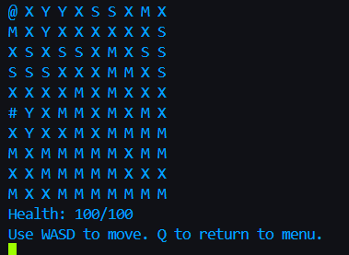
Figure 1: An example of the map taken from the Project, the player is represented through the “@” symbol and enemy is represented through “#”

This section focuses on the overall game design itself and the main components that interact with the gameplay experience. The game is a grid-based console-based game environment where the player navigates through a procedurally generated map while interacting with enemy entities and other gameplay mechanics.

The game is designed through an object-oriented architecture that contains different components which have responsibilities for specific aspects of the application. The game environment defines the overall structure of the map and the terrains within the map that influence movement for both the player and enemy. The player’s components include user-controlled navigation, character attributes, and its interaction with the environment. Enemies represent the hostile agents who try to pursue the player through the map via A* pathfinding algorithm and then during the battle system the enemy’s main objective is to try and defeat the player strategically with the tools and spells that it has within its hands.

Together, these components allows the game to make a clear separation of responsibilities and at the same time an intertwined operation which work together given its process of player input, enemy behavior and interactions between entities within the environment.

Game Map

The Game Environment is represented through a two-dimensional grid that is composed of terrain tiles that are represented with a character. Instead of relying on predefined map layouts, the game uses Procedural Map Generation to produce different maps which ensure that each playthrough creates a different environment while maintaining its current logical terrain relationships.

In order to generate the map though, the project uses Wave Function Collapse (WFC). Created by Maxim Gumin and based on work by Paul Merrell, WFC is a procedural map generation technique that was originally used to develop simple configuration or sample images, in video games it has been used to generate adjacent constraints from element to element. The function operates through checking tiles that are adjacent to one another, e.g. grass can be next to water, but mountains cannot.

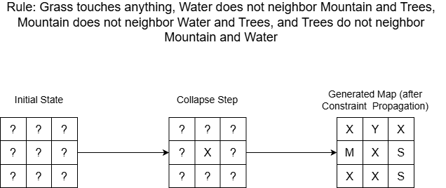
Figure 2: A diagram showcasing the process of the Wave Function Collapse (WFC) in this project, X is grass, Y is tree, S is water, M is mountain

Initially, all grid cells are assigned a set of possible tiles that would be assigned to them. This is the highest level of entropy, which is the many possible tiles and the cell that has not been assigned a specific terrain yet. Then, the function goes on a loop to select the cell that has the lowest entropy cell, meaning the cell with the fewest possible tiles.

After that, once a terrain is chosen for the cell, a constraint propagation is performed. Constraint propagation updates their possible terrain states based on the defined adjacency restrictions. These adjacency restrictions define what terrain type is allowed to neighbor next to the other. Therefore, grass can neighbor anything, mountain neighbors grass and itself, the tree neighbors anything but water, and water only neighbors the grass and itself.

Through constraint propagation, it allows for the number of possible tiles on a cell to be reduced depending on the neighboring cells. This, in turn, influences the selections made by the function. This entirely continues looping until every cell within the map grid has been assigned a single terrain type which leads to a filled map that has the defined terrain constraints.

Through WFC, this map system does not require a predefined map but rather a random set of tiles that still have a structural consistency to them. This leads to the environment having a variety yet at the same time coherency during different game sessions.

Player
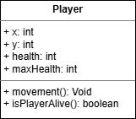
Figure 3: A UML Diagram showcasing the Player class, the variables it contains, and its methods

The player is practically what the user controls within the game environment. The player navigates the grid-based procedurally generated map while avoiding the terrain and either avoiding or attempting to defeat the enemies.

The player occupies a position on the cell and during each turn of the game loop they can move in four directions: up, down, left, and right. Movement is done through a keyboard input which allows the user to explore the map one step at a time. One step takes a turn within the game map.

Like the enemy, the player is constrained by the environmental rules. Terrain types such as mountains and water serve as an obstacle for the player. If the player attempts to try to move into a mountain or a water the movement would be prevented and the player would stay in their current position. However, unlike the enemy, the player would eventually be able to move through these blocked pathways if they receive the correct item to pass through mountains and/or manage to acquire the spell that would allow them to pass through water. These constraints make sure that the player is initially navigating an environment according to the initial logical structure of the terrain. The player will have to progress through the game further in order to liberate themselves from some of the restrictions if they receive the proper item and/or spell.

In addition to movement, the player has two main important attributes representing their current state during the game: health and mana. Health determines the player’s survival during encounters with the enemy, while mana is a resource used for casting spells during combat or exploration. If the player’s health reaches zero, the game ends and the player would have to replay the game starting from where they last saved. Spells include offensive and defensive abilities, which also include providing buffs during combat. Items serve the same case though it is more a strategic toolkit that, depending on the lifespan of those items, can disappear from the player’s inventory if it is used more than the maximum amount of uses it has.

With this player system, the player is the central agent of the game, it allows for an interactive user experience and leads to the player having to explore their game environment, navigation, combat, and resource management.

Enemy

Enemies are the hostile entities within the game that pursue the player throughout the environment. Their main mission is to locate and reach the player’s position within the grid-based map. In contrast to the player who is controlled by the user, the enemy is considered a non-playable character (NPC), controlled by an artificial intelligence system.

Enemies occupy a position on the cell, and during each turn of the game loop the enemy evaluates the current position of the player and begins determining how to move closer to the player’s position. This behavior is more efficient and interactive for the player as rather than having the enemy move randomly throughout the environment, they’re instead actively chasing the player.

Just like the player, though, the enemy is constrained by environmental rules. Terrain types such as mountain serve as an obstacle to the enemy and, therefore, results in the enemy having to navigate around the obstacles in order to reach the player. To determine an efficient route that would lead the enemy towards the player while also avoiding obstacles that come in their way, the enemy’s movement uses A* pathfinding algorithm.

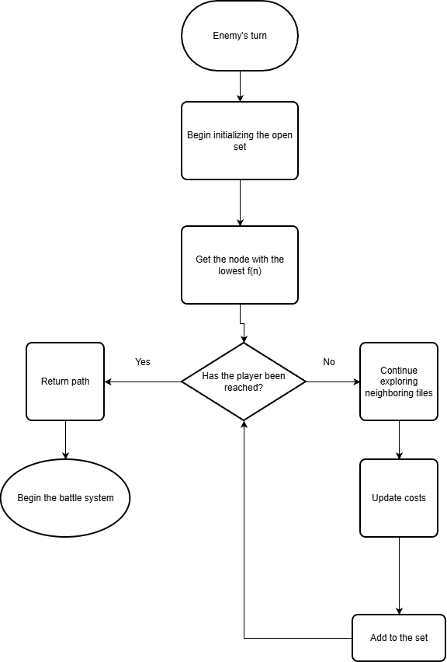
Figure 4: Enemy’s pathfinding using A* pathfinding algorithm where the enemy tries to find the shortest and most efficient way to reach the player while also avoiding impassable terrains

A* pathfinding algorithm is an algorithm that finds the shortest path between a starting node and a goal node within a weighted graph. It combines two algorithms, Dijkstra’s algorithm which tries to find the shortest path to all nodes from a single node source and Greedy Best-First Search which explores the node that appears closest to the goal based on a heuristic function. However, what makes A* more efficient for enemy movement is that A* considers the distance that was already traveled from the start and an estimate of the remaining distance to the goal, this is in comparison to Dijkstra’s algorithm which explores in all directions and Greedy Best-First search which only heads straight towards the destination rather than looking for shortcuts.

A* operates through an evaluation of nodes using a cost function which is defined as:

f(n) = g(n) + h(n)

While g(n) represents the cost required to reach the node n from the starting position, h(n) represents the heuristic estimate of the distance from node n to the goal. In this instance, the heuristic is calculated through the Manhattan distance which works for a grid-based environment such as this game map where the enemy can move horizontally or vertically.

During execution, A* maintains two main sets of nodes. The open set contains nodes which are still to be explored while the closed set are nodes that have already been explored. Within each step of the algorithm, the node with the estimated lowest total cost of f(n) which is selected from the open set and further expanding when exploring the neighboring nodes. Mountains, which are an obstacle to the enemy, are excluded from the search.

Once A* finds the player’s position, it tries to reconstruct the shortest path by tracing the parent nodes from starting position to the goal. The enemy then moves one step along this path per game turn.

Through A* program which relies on the grid-based procedurally generated map, enemies can navigate through a complex terrain to try and chase the player. It makes it so that the enemy has a purpose when it decides on its movement and responds to its environment rather than having random movements until it finds the enemy.

When the enemy reaches the player’s position, a turn-based combat encounter begins. During this combat, enemies can perform physical attacks, use their own items, or employ abilities that they would have that affects the battle.

Providing the enemy with similar combat mechanics to the player allows for a fairer and challenging game for the player who would have to strategize in their moves to ensure the enemy’s defeat. It adds more complexity and depth into the gameplay for the player but maintains a clear relationship in exploration, enemy behavior especially in the sphere of artificial intelligence, and their combat system.

Combat System

When the player decides to go for the enemy or the enemy reaches the player’s position, the game transitions from a grid-based look to a turn-based battle system similar to ones seen in games such as Pokémon. Here, both the player and whether it is one enemy or more take turns until either the player or the enemy sides becomes triumphant.

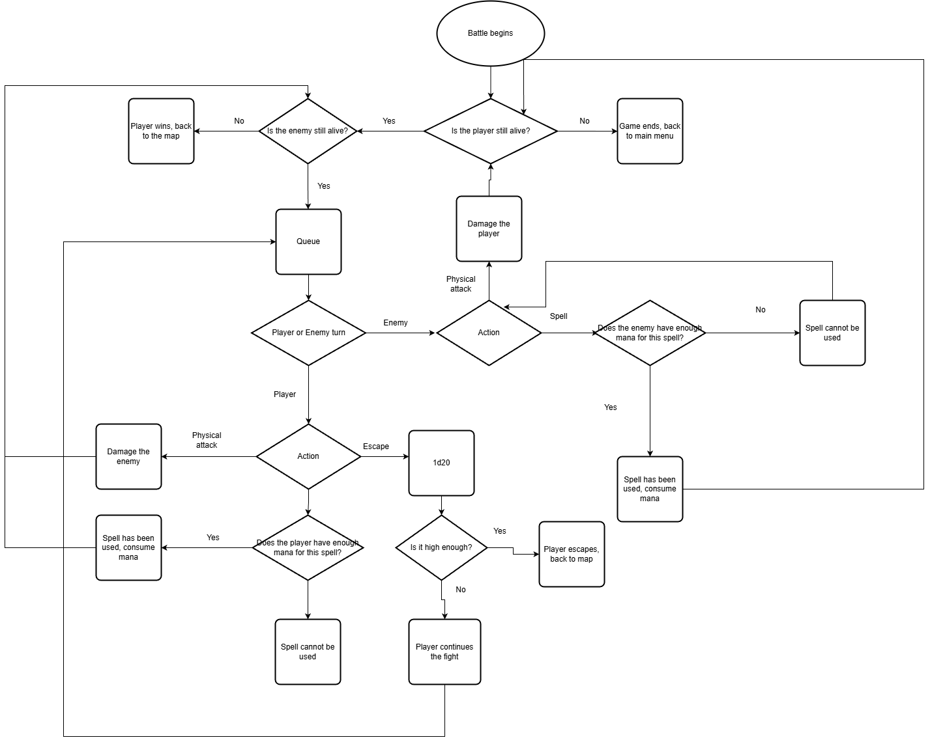
Figure 5: Flowchart of the battle system explaining the decisions being taken by the player and enemy and how the system determines what to do next

Combat uses a turn-based structure where, during each turn, the player is set of available actions that would affect the outcome of the battle. This includes physical actions, spells, items, and an attempt to escape combat. After the player performs an action, the enemy begins its own response to the player’s actions depending on its behavior.

In the case that the player is fighting multiple enemies, the battle system goes through a turn order via a priority queue data structure. The players and enemies are placed into a queue and have a priority value set to them that determines the order the actions will be performed in. This structure makes sure that there’s a consistent and organized queue so that each entity has their own turn for an action, especially if there is more than one enemy present in the battle.

Both players and enemies have two important attributes that affect the combat outcomes: health and mana. Health is each entity’s survival during a battle; it represents how long they can hold for until it reaches 0. Once the player reaches 0 the game is over and they would have to load back to the save file to continue from the last saved game state. If the player is facing one enemy and the enemy reaches 0, then the player would be victorious and the enemy is removed from the environment, and there would be chances of items or, even in rarer cases, for the player to receive a book to learn a new spell. In the case that the player is facing multiple enemies, if one enemy’s health reaches 0, they are removed from the queue and from the environment, keeping the structure intact with the change of one less enemy. Mana is more of the number of times the player is allowed to use spells or special abilities, if the player or an enemy use a spell a certain number of mana is consumed.

The player also has the other option to escape combat. When the player presses the run option, a 1d20 dice is rolled and it considers the player and enemy’s health, with the dice’s lower roll chances being increased if the player’s health is low or the higher roll chances being increased if the enemy’s health is low. The player is able to increase their chances if, during one of the actions, they use a spell that allows their chances of escape to increase. The enemy may also do the same to make it more difficult for the player to escape. This is to make sure that the player has an option to risk trying to escape combat but at the same time ensures that the player does not consistently escape combat and may even lead them to try to fight the enemy.

Through integrating the combat system and enemy behavioral decisions, the game has a unified gameplay loop which although the environment and battle would seem separate, at the same time unites the game as a whole with its diversity and interactions.

Saving and loading system

In many RPG games, a saving and loading system is set so that the player does not lose progress during their gameplay and it makes it easier for them to continue their progress at a later point. In this game, the saving system records essential information about the current game state including the player’s attributes: health, mana, position, and inventory alongside the current state of the environment and the information regarding the enemy entities so that the game progress is still consistent when loading.

The data is then recorded into an external JSON file when a save is performed. The file contains the necessary structured data that would represent the game at its current state once saved. Then, when the player later loads into the game the system reads the stored data and starts putting back the game all the way to its state when it was first saved. In addition to the user being able to manually save, the system also performs an automatic saving before a battle begins and after it ends. This is to ensure that important parts of the gameplay are preserved and so that the player is able to return to the game progress if the game is interrupted.

There are three slots the player can create a new game on. If the player chooses to create a new game on a previously saved slot, they have the option to override the existing data and the save file will start off with a fresh clean slate. This allows the player to have multiple playthroughs and at the same time have the choice to override older saves with new run-throughs.

The saving and loading functionalities are managed by a dedicated part of the game’s architecture. This part handles file management such as inputting save data and taking out the data when loading into a game.

Although it separates from the usual gameplay, saving and loading helps the user have the choice to save their game progress and at the same time the other option to load into their progress in case of any interruptions.

Implementation

This section describes the implementation programming, approaches and tools that have been used to develop the game. The game was implemented as a console-based game that integrates procedural map generation, artificial intelligence navigation and behavior, and turn-based gameplay mechanics within an object-oriented system architecture.

The implementation focuses on turning the system design described in previous sections into a proper game. Core components including the game environment, user-controlled player, enemy behavior system, and combat mechanics were implemented as independent classes which, although separate from each other, interact through the central game loop.

This structure allows the system to remain organized and maintainable yet showcasing a more complex gameplay with challenges for the player during the game.

Programming languages, libraries, and external frameworks

The game was created through Java 19. Java was chosen as the programming language due to its strong support for object-oriented programming, extensive standard already-built libraries for data structures, input handling, and implantation of algorithms.

Java is also great if the game is played on different operating systems such as Windows, Linux, and Mac due to the Java Virtual Machine (JVM) which allows itself to be an intermediary between the compiled program and the operating system. This design allows java programs to be able to be written on one different operating system and run on whichever operating system making it well-suited for cross-platform software and, for this instance, game development.

The system is fully reliant on Java’s already existing standard library. Java’s Collections Framework is used throughout the program for the sets and lists which are seen in possible tile states via the Wave Function Collapse (WFC) and priority queues in A* pathfinding algorithm to evaluate nodes during the search process.

No external frameworks or libraries have been used for this project, all the necessary functionalities use Java’s already built-in libraries.

Installation Requirements

The following is required in order to compile and run the game:

- JDK 9 or above
- Operating systems such as Windows, Mac, or Linux
- A command-line interface or an environment that allows for compiling and running Java applications

Before running the program, the path shown on the terminal is set to \...\turnBasedGame\src then compile it by writing the following on the terminal:
javac *.java
Once the compiling is complete, the program can be executed by writing on the terminal:
java App
If the user sees the main menu, which contains “1. New Game, 2. Load Game, 3. Quit”, then the program is running and the user is free to play the game.

References
https://github.com/mxgmn/WaveFunctionCollapse
https://www.boristhebrave.com/2020/04/13/wave-function-collapse-explained/
https://paulmerrell.org/model-synthesis/
https://theory.stanford.edu/~amitp/GameProgramming/AStarComparison.html
https://www.datacamp.com/tutorial/a-star-algorithm
https://www.baeldung.com/cs/a-star-algorithm
https://docs.oracle.com/javase/8/docs/technotes/guides/vm
https://www.youtube.com/watch?v=Ae_zvm0-CQU&t
https://medium.com/@jonathonmcclendon/rpg-leveling-systems-to-keep-players-coming-back-db83b79a9a04

